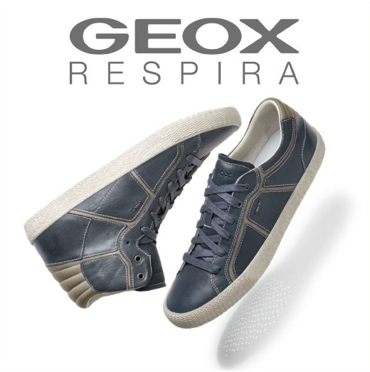

FALL **WINTER** 2013-2014 **KIDS** COLLECTION

|  |  |
| --- | --- |
| **Auriga**  Vitam fuga. Iquaepedic **torem** incium eum *con* plaborrum Labo.   * Pistia quid que apis eium * Eera iliquasperem faccuptatia * Volupta tessus   Image courtesy of Giovanni Carraro / Italy |  |

|  |  |  |  |  |  |  |  |  |
| --- | --- | --- | --- | --- | --- | --- | --- | --- |
|  | **CODE** | **DESCRIPTION** | **SIZE** | **MATERIAL** | **COLOR** | **FEATURES** | **PRICE** | **BARCODE** |
|  | CODE 1 | Custom code description 1 | 22-37 | Leather | Black |  | 99,99 | ,!8HG5E3-cbjfeb! |
|  | CODE 2 | Custom code description 2 | 22-37 | Leather | Black |  | 99,99 | ,!8HG5E3-cbjfeb! |

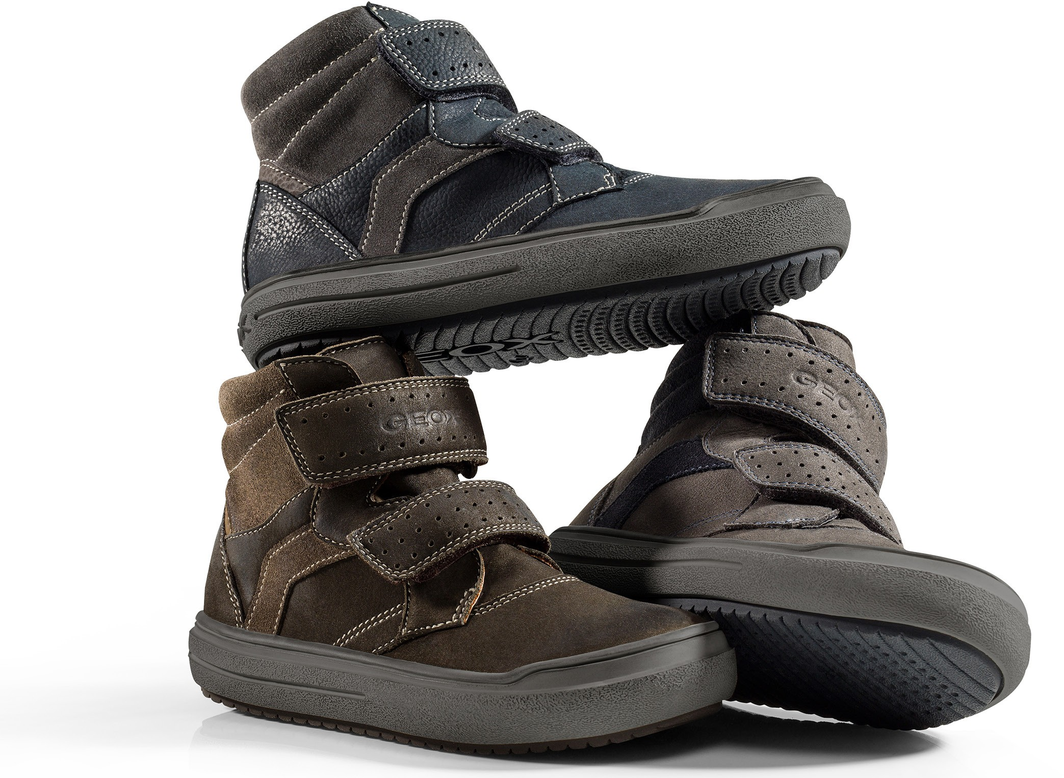

Urban

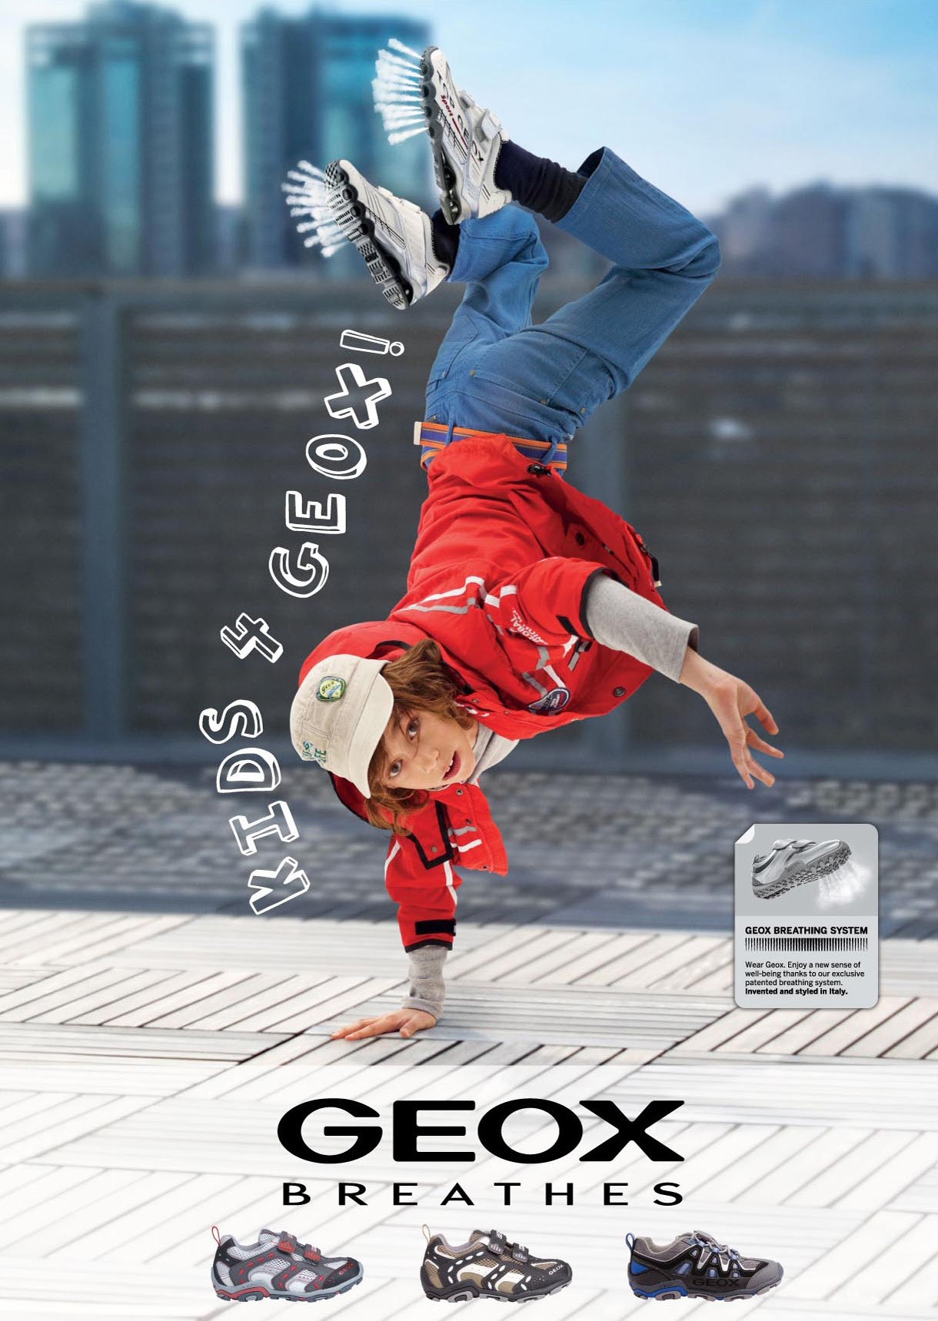

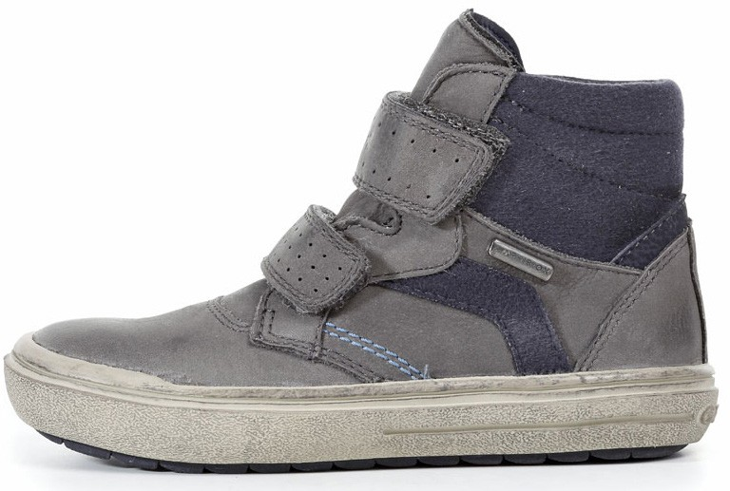Auriga 2

Vitam fuga. Iquaepedic **torem** incium eum *con* plaborrum Labo. Pistia quid que apis eium Eera iliquasperem faccuptatiaVolupta tessus Image courtesy of Giovanni Carraro / Italy

|  |  |  |  |
| --- | --- | --- | --- |
|  | **CODE** | **DESCRIPTION** | **PRICE** |
|  | CODE 1A | Custom code description 3 | 99,99 |
|  | CODE 2A | Custom code description 4 | 99,99 |

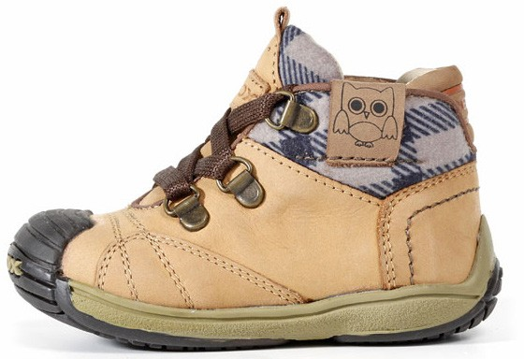Cignus

Vitam fuga. Iquaepedic **torem** incium eum *con* plaborrum Labo. Pistia quid que apis eium Eera iliquasperem faccuptatiaVolupta tessus Image courtesy of Giovanni Carraro / Italy

|  |  |  |  |
| --- | --- | --- | --- |
|  | **CODE** | **DESCRIPTION** | **PRICE** |
|  | CODE 5 | Custom code description 5 | 99,99 |
|  | CODE 6 | Custom code description 6 | 99,99 |

Active

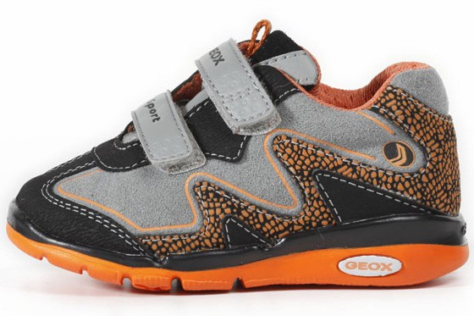Libra

Vitam fuga. Iquaepedic **torem** incium eum *con* plaborrum Labo. Pistia quid que apis eium Eera iliquasperem faccuptatiaVolupta tessus Image courtesy of Giovanni Carraro / Italy

|  |  |  |  |
| --- | --- | --- | --- |
|  | **CODE** | **DESCRIPTION** | **PRICE** |
|  | CODE 3 | Custom code description 7 | 99,99 |
|  | CODE 4 | Custom code description 8 | 99,99 |

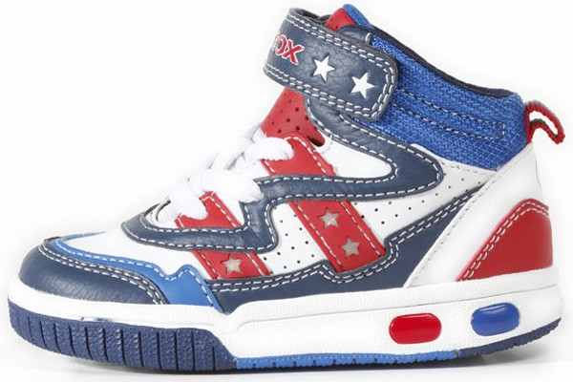Hercules

Vitam fuga. Iquaepedic **torem** incium eum *con* plaborrum Labo. Pistia quid que apis eium Eera iliquasperem faccuptatiaVolupta tessus Image courtesy of Giovanni Carraro / Italy

|  |  |  |  |
| --- | --- | --- | --- |
|  | **CODE** | **DESCRIPTION** | **PRICE** |
|  | CODE 7 | Custom code description 9 | 99,99 |
|  | CODE 8 | Custom code description 10 | 99,99 |

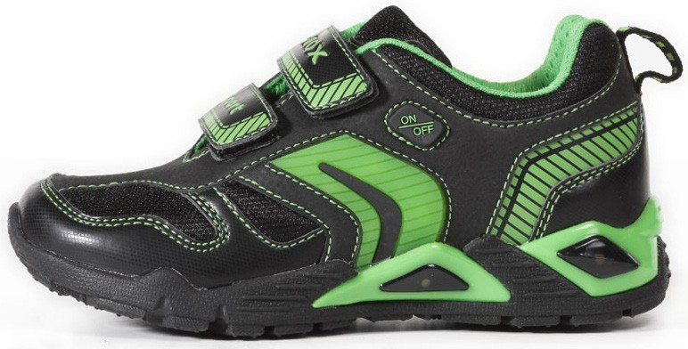Pegasus

Vitam fuga. Iquaepedic **torem** incium eum *con* plaborrum Labo. Pistia quid que apis eium Eera iliquasperem faccuptatiaVolupta tessus Image courtesy of Giovanni Carraro / Italy

|  |  |  |  |
| --- | --- | --- | --- |
|  | **CODE** | **DESCRIPTION** | **PRICE** |
|  | CODE 9 | Custom code description 11 | 99,99 |
|  | CODE 10 | Custom code description 12 | 99,99 |

AURIGA . . . . . . . . . . . . . . . . . . . . . . . . . . . . . . . . . . . . . . . . . . . . . . . . . . . . . . . . . . . . . . . . . . . . . . . . . . . . . . . . . . . . . . . . . . . . . . . . . .

|  |  |  |  |  |  |  |  |  |  |
| --- | --- | --- | --- | --- | --- | --- | --- | --- | --- |
|  | **CODE** | **DESCRIPTION** | **SIZE** | **MATERIAL** | **COLOR** | **PRICE** | **BARCODE** |  | **PAGE** |
|  | CODE 5 | Custom code description 5 | 22-37 | Leather | Black | 99,99 | ,!8HG5E3-cbjfeb! |  | **PAGE 2** |
|  | CODE 6 | Custom code description 6 | 22-37 | Leather | Black | 99,99 | ,!8HG5E3-cbjfeb! |  | **PAGE2PAGE 4** |

|  |  |  |  |  |  |  |  |  |  |  |
| --- | --- | --- | --- | --- | --- | --- | --- | --- | --- | --- |
|  | **CODE** | **DESCRIPTION** | **SIZE** | **MATERIAL** | **COLOR** | **FEATURES** | **PRICE** | **BARCODE** |  | **PAGE** |
|  | CODE 1 | Custom code description 1 | 22-37 | Leather | Black |  | 99,99 | ,!8HG5E3-cbjfeb! |  | **PAGE 2** |
|  | CODE 2 | Custom code description 2 | 22-37 | Leather | Black |  | 99,99 | ,!8HG5E3-cbjfeb! |  | **PAGE 2** |

AURIGA 2 . . . . . . . . . . . . . . . . . . . . . . . . . . . . . . . . . . . . . . . . . . . . . . . . . . . . . . . . . . . . . . . . . . . . . . . . . . . . . . . . . . . . . . . . . . . . . . . . . .

|  |  |  |  |  |  |  |  |  |  |
| --- | --- | --- | --- | --- | --- | --- | --- | --- | --- |
|  | **CODE** | **DESCRIPTION** | **SIZE** | **MATERIAL** | **COLOR** | **PRICE** | **BARCODE** |  | **PAGE** |
|  | CODE 5 | Custom code description 5 | 22-37 | Leather | Black | 99,99 | ,!8HG5E3-cbjfeb! |  | **PAGE2P4** |
|  | CODE 6 | Custom code description 6 | 22-37 | Leather | Black | 99,99 | ,!8HG5E3-cbjfeb! |  | **PPAGE2PAGE 4** |

|  |  |  |  |  |  |  |  |  |  |  |
| --- | --- | --- | --- | --- | --- | --- | --- | --- | --- | --- |
|  | **CODE** | **DESCRIPTION** | **SIZE** | **MATERIAL** | **COLOR** | **FEATURES** | **PRICE** | **BARCODE** |  | **PAGE** |
|  | CODE 1 | Custom code description 1 | 22-37 | Leather | Black |  | 99,99 | ,!8HG5E3-cbjfeb! |  | **PAGE 2** |
|  | CODE 2 | Custom code description 2 | 22-37 | Leather | Black |  | 99,99 | ,!8HG5E3-cbjfeb! |  | **PAGE 2** |

CIGNUS . . . . . . . . . . . . . . . . . . . . . . . . . . . . . . . . . . . . . . . . . . . . . . . . . . . . . . . . . . . . . . . . . . . . . . . . . . . . . . . . . . . . . . . . . . . . . . . . . .

LIBRA . . . . . . . . . . . . . . . . . . . . . . . . . . . . . . . . . . . . . . . . . . . . . . . . . . . . . . . . . . . . . . . . . . . . . . . . . . . . . . . . . . . . . . . . . . . . . . . . . . . .

# KID

HERCULES . . . . . . . . . . . . . . . . . . . . . . . . . . . . . . . . . . . . . . . . . . . . . . . . . . . . . . . . . . . . . . . . . . . . . . . . . . . . . . . . . . . . . . . . . . . . . . . .

|  |  |  |  |  |  |  |  |  |
| --- | --- | --- | --- | --- | --- | --- | --- | --- |
|  | **CODE** | **DESCRIPTION** | **SIZE** | **MATERIAL** | **COLOR** | **PRICE** | **BARCODE** | **PAGE** |
|  | CODE 7 | Custom code description 9 | 22-37 | Leather | Black | 99,99 | ,!8HG5E3-cbjfeb! | **PAGE 5** |
|  | CODE 8 | Custom code description 10 | 22-37 | Leather | Black | 99,99 | ,!8HG5E3-cbjfeb! | **PAGE 5** |

|  |  |  |  |  |  |  |  |  |
| --- | --- | --- | --- | --- | --- | --- | --- | --- |
|  | **CODE** | **DESCRIPTION** | **SIZE** | **MATERIAL** | **COLOR** | **PRICE** | **BARCODE** | **PAGE** |
|  | CODE 9 | Custom code description 11 | 22-37 | Leather | Black | 99,99 | ,!8HG5E3-cbjfeb! | **PAGE 5** |
|  | CODE 10 | Custom code description 12 | 22-37 | Leather | Black | 99,99 | ,!8HG5E3-cbjfeb! | **PAGE 5** |

PEGASUS . . . . . . . . . . . . . . . . . . . . . . . . . . . . . . . . . . . . . . . . . . . . . . . . . . . . . . . . . . . . . . . . . . . . . . . . . . . . . . . . . . . . . . . . . . . . . . . . .

7